
Dashboard Design

Date | 02 November 2026
Team ID | NA
Project Name | Electric Vehicle Market Performance & Insights
Maximum Marks | 5 Marks

Creating an effective dashboard involves thoughtful design to ensure that the presented information is clear, relevant, and easily understandable for the intended audience. Here are some key principles and best practices for dashboard design
Activity 1: Interactive and visually appealing dashboards
Creating interactive and visually appealing dashboards involves a combination of thoughtful design, effective use of visual elements, and the incorporation of interactive features. Here are some tips to help you design dashboards that are both visually appealing and engaging for users so take care of below points
- Clear and Intuitive Layout
- Use Appropriate Visualizations
- Colour and Theming
- Interactive Filters and Slicers
- Drill-Down Capabilities
- Responsive Design
- Custom Visuals and Icons
- Use of Infographics

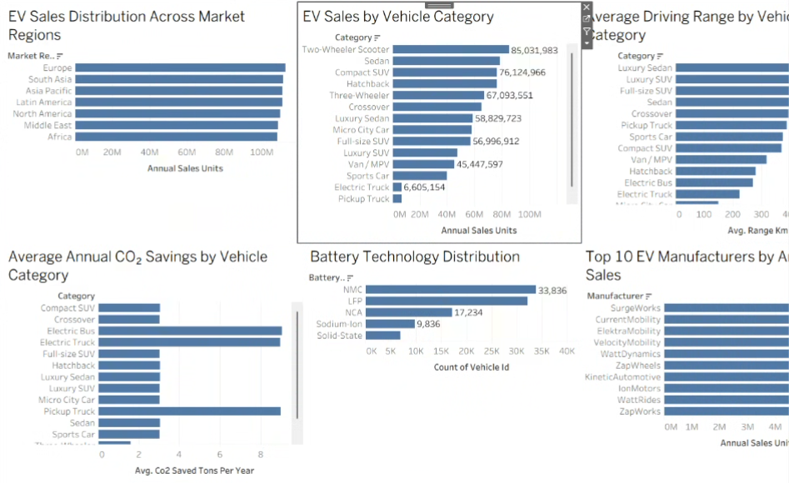
Key outcomes of my EV Market Dashboard:
Five main outcomes:
- Urban mobility leads sales: Two-Wheeler Scooters (85.0 M units), Sedans (78.3 M) and Compact SUVs (76.1 M) are the best-selling categories, while buses and trucks sell under 7 M units each.
- Balanced global demand: All seven market regions sell between 108 M and 113 M units, with Europe slightly ahead – companies can target every region, not just one.
- No dominant brand: SurgeWorks leads with 4.88 M units, yet the top 10 manufacturers hold only about 6% of sales, so competition is wide open.
- NMC and LFP batteries dominate: NMC (33,836) and LFP (32,101) power about two-thirds of vehicles; Solid-State (6,993) is still emerging.
- Range and CO₂ trade-off: Luxury Sedans give the longest range (549 km), while Electric Buses, Pickup Trucks and Electric Trucks save the most CO₂ per vehicle (about 9 t/yr).
Overall: affordable urban EVs drive volume, demand is balanced across regions, no brand dominates, NMC and LFP batteries lead, and heavy electric vehicles give the largest CO₂ savings – answering the questions of Emily, David and Sarah.

Activity 2
Publish Dashboard on Tableau Public and Paste the Dashboard Public link below:
Dashboard public link:
https://public.tableau.com/app/profile/parvi.sharma/viz/ElectricVehicleMarketPerformanceandInsights/EVMarketDashboard

